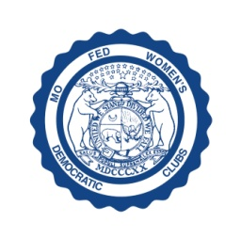
MISSOURI FEDERATION OF WOMEN’S DEMOCRATIC CLUBS
DUE DATE: April 21, 2021

Please return this form with your state dues to: Cathy Spainhower, MFWDC Treasurer
Payable upon receipt of this form 3512 Bridge Manor Dr., Kansas City, MO 64137
Deadline: April 21, 2021 816-305-3229
Congressional District ______County________________________________________
Club Name____________________________________________________________
Club President__________________________________________________________ Address______________________ City_________________________ Zip:______________
Phone ( ) _____________ E-mail Address________________________________________
Club Treasurer _________________________________________________________
Address___________________________ City______________________ Zip:______________
Phone ( ) _______________E-mail Address: _____________________________________
Number of Members ___________Amount enclosed @ $1.00 per member $______________

Make checks payable to: Missouri Federation of Women’s Democratic Clubs (MFWDC)
Missouri Federation of Women’s Democratic Clubs’ Bylaws
Relating to club delegates to the state convention:
Article IX: Section 3: Clubs are entitled to representation as follows: One (1) delegate for each ten (10) members upon whom per capita dues of $1.00 have been paid.
Article V: Section 1: District dues must be paid to the district treasurer. Section 2: Dues shall be payable
to the treasurer of the Federation not less than forty-five (45) days prior to the state convention.

Specify to whom the RESPONSE LETTER is to be sent: Name______________________________________________________________________________ Signed: Club President _______________________________________________________________
Address _________________________City______________________________Zip_______
E-Mail Address ___________________________ Phone______________________________

DUES MUST BE POSTMARKED NO LATER THAN April 21,2021. DELEGATE AND ALTERNATE CARDS WILL BE AVAILABLE AT CONVENTION REGISTRATION. A LETTER OF ELIGIBILITY FOR DELEGATES WILL BE MAILED TO YOUR CLUB AT THE ABOVE SPECIFIED ADDRESS.

DISTRICT DUES
MUST BE PAID TO YOUR DISTRICT TREASURER PURSUANT TO DISTRICT BY-LAWS: The District dues are paid to the district treasurer, and the monies stay at the district level, as are State dues paid to the State treasurer, and the monies are used at the State level. Both State and local dues should be paid to insure voting privileges at the convention.

